The behaviour of Severe Tropical Cyclone Marcia
The image below details the path that severe Tropical Cyclone Marcia took in 2015.
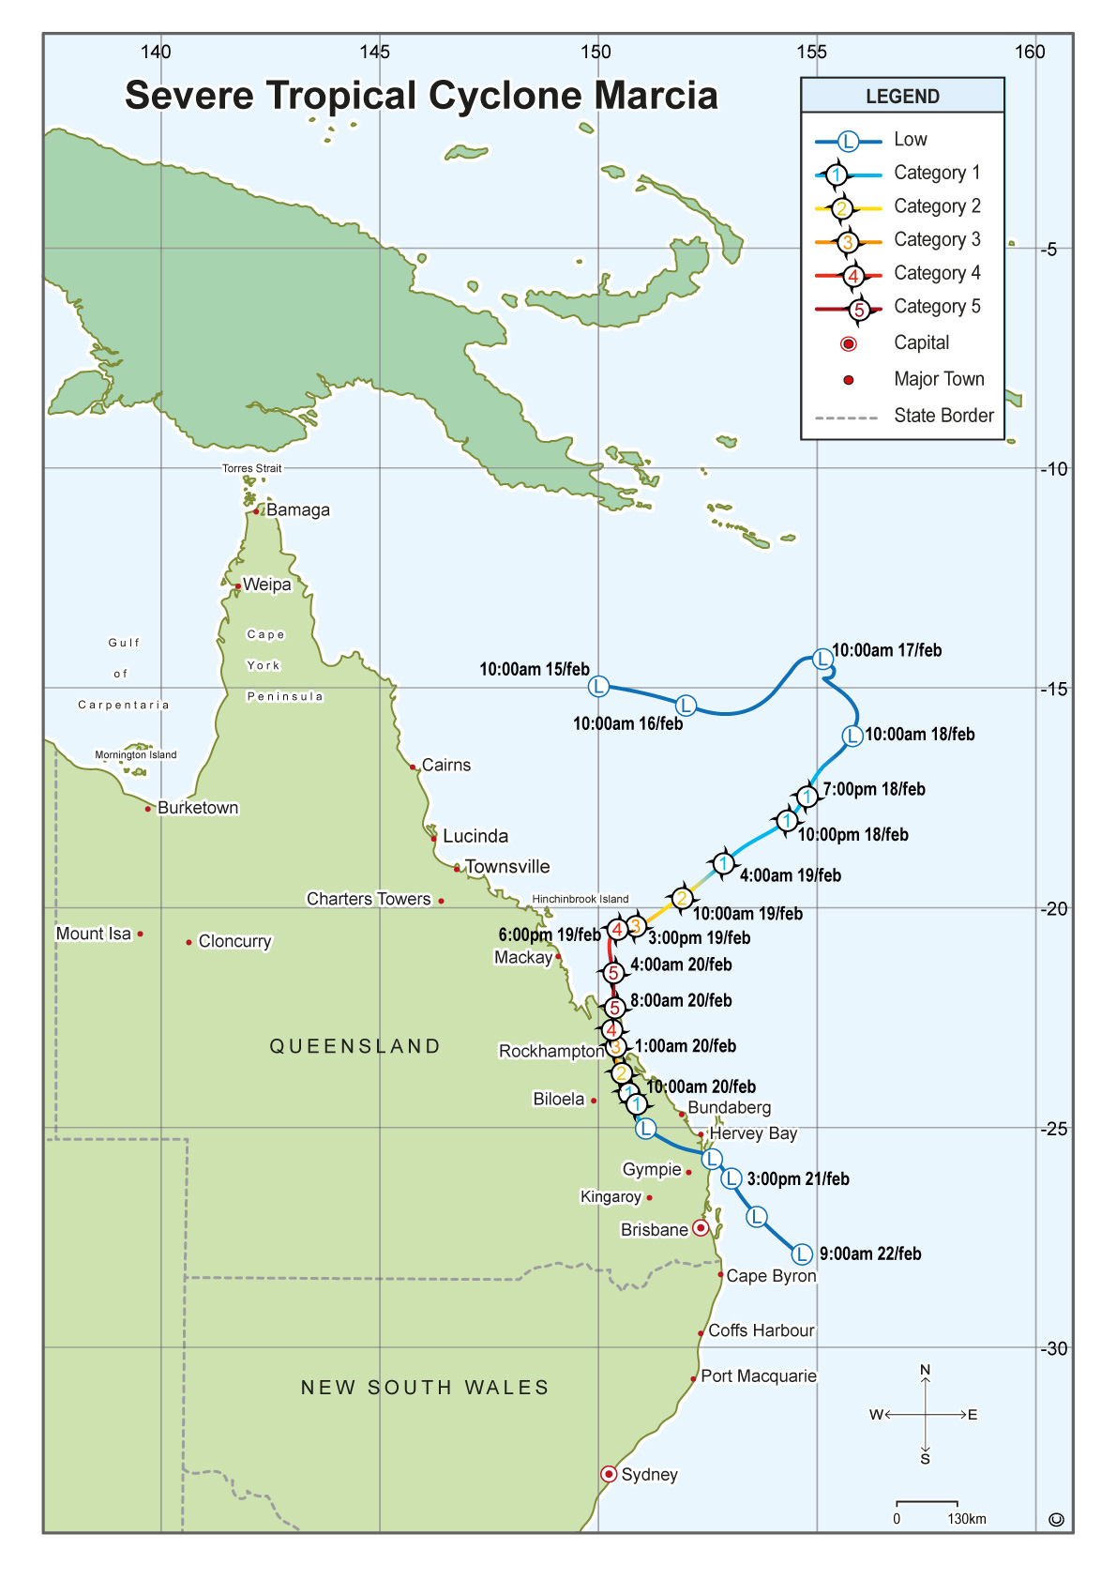
Severe Tropical Cyclone Marcia was named on Wednesday 18 February 2015 after beginning as a tropical low on 15 February. At its peak, Tropical Cyclone Marcia was identified as a category 5 cyclone with wind gusts of 208 km/h. When it made landfall at Shoalwater Bay, north of Yeppoon wind gusts of 156 km/h were recorded. Areas affected included towns in Central Queensland including Rockhampton that experienced wind gusts of 113 km/h, and Biloela which recorded winds of 85 km/h. Towns further south were impacted with heavy rain, flooding and high tides. Marcia was downgraded to a low on Saturday 21 February.
Marcia impacted over 60 000 homes creating extensive structural damage, loss of power, and mass destruction of large trees and other vegetation.

